

# *UniX and Linux Essentials*

**ASSIGNMENT -11**

**SUBMITTED BY:**

**AYUSH KUMAR JHA**

**SAP ID - 500086400**

**Enrollment no - R200220083**

**B.C.A -I.O.T.**

**Assignment 11 :-**

* **VI version check**

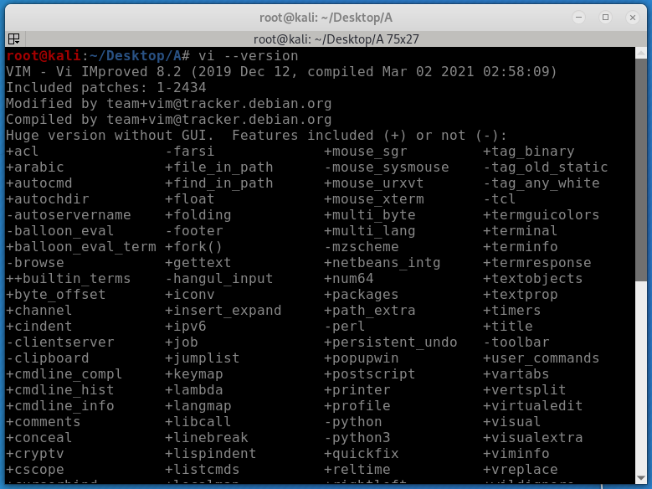

* **Vi help**

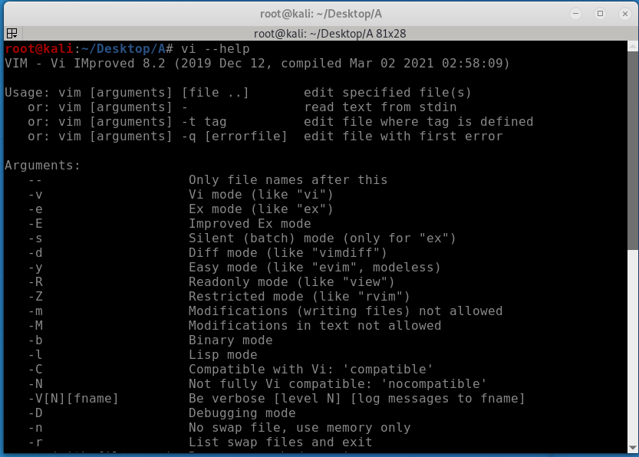

* **Vi clean**

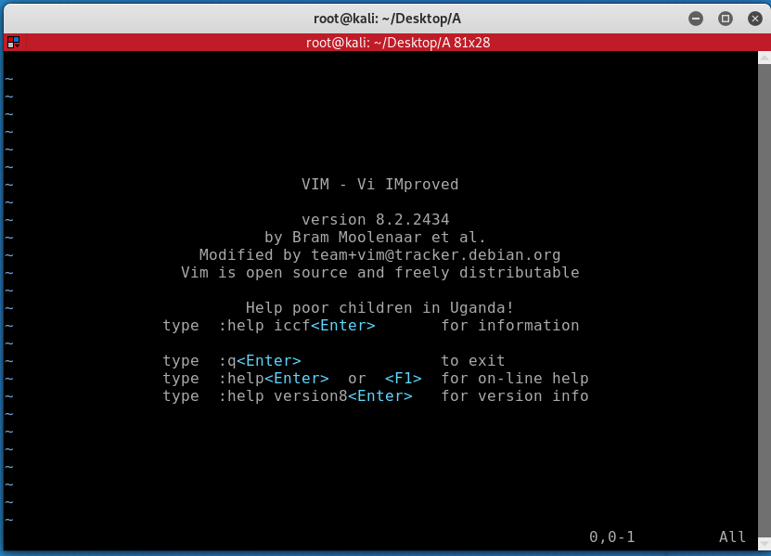

* **Start Up time**

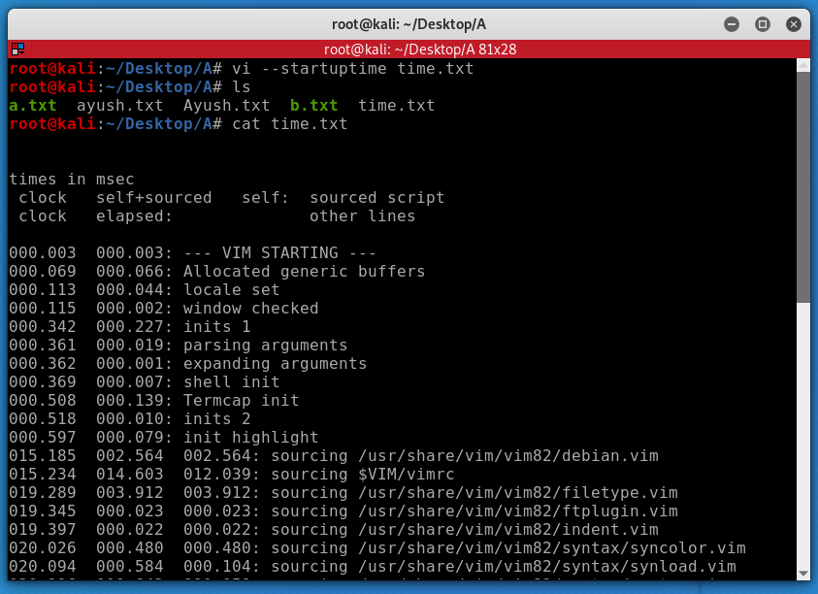

* **Execute command before opening**

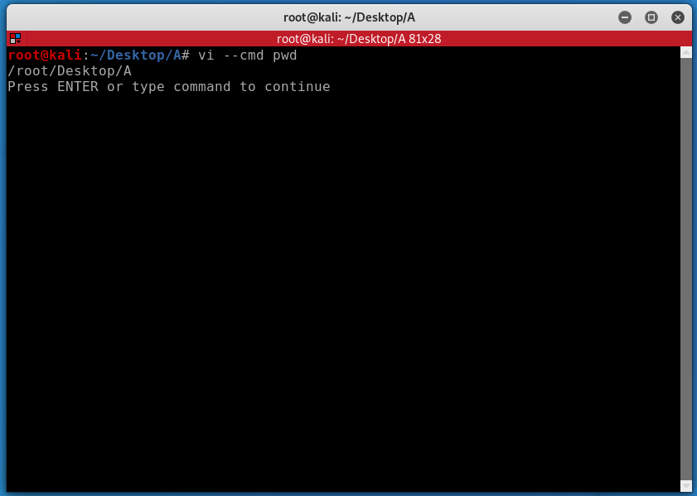

* **Execute after the first file**

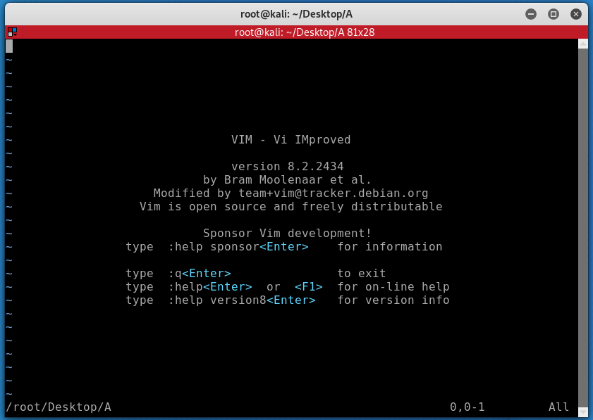

* **Start in Arabic mode**

